**ASSIGNMENT 1 FRONT SHEET**

|  |  |  |  |
| --- | --- | --- | --- |
| **Qualification** | **BTEC Level 5 HND Diploma in Computing** | | |
| **Unit number and title** | Unit 16: Cloud computing | | |
| **Submission date** |  | **Date Received 1st submission** |  |
| **Re-submission Date** |  | **Date Received 2nd submission** |  |
| **Student Name** | Bùi Hương Linh | **Student ID** | GBH200662 |
| **Class** | GCH1002 | **Assessor name** | Đỗ Quốc Bình |
| **Student declaration**  I certify that the assignment submission is entirely my own work and I fully understand the consequences of plagiarism. I understand that making a false declaration is a form of malpractice. | | | |
|  |  | **Student’s signature** | Linh |

**Grading grid**

|  |  |  |  |  |  |  |
| --- | --- | --- | --- | --- | --- | --- |
| P1 | P2 | P3 | P4 | M1 | M2 | D1 |
|  |  |  |  |  |  |  |

|  |  |  |
| --- | --- | --- |
| **❒ Summative Feedback: ❒ Resubmission Feedback:** | | |
| **Grade:** | **Assessor Signature:** | **Date:** |
| **Internal Verifier’s Comments:** | | |
| **Signature & Date:** | | |

Table of Contents

Introduction 5

I. Overview cloud computing 5

II. Client – Server 5

1. Client 5

2. Server 5

3. Relation between Client and Server 6

III. Peer – to – peer(P2P) 7

IV. High Performance Computing 7

1. Parabel 7

2. Cluster 8

3. Distributed 8

V. Deployment Models 9

1. Public deployment 9

2. Private deployment 10

3. Community cloud 11

4. Hybrid cloud 12

VI. Cloud Server Models 14

1. Infrastructure as a Service (IAAS) 14

2. Platform as a Service (PAAS) 15

3. Software as a Service (SAAS) 16

VII. Characteristic of Cloud 18

VIII. Virtualization and Multicore 18

1. Virtualization 18

2. Multicore 19

IX. Solution for ATN 19

1. Scenario 19

2. Solution 19

3. Deployment Model 19

4. Service Model 20

5. Technical Specs 20

5.1. NodeJS 20

5.2. MongoDB 21

5.3. Render 21

Conclusion 22

References 22

Figure 1: Public deployment 10

Figure 2: Private deployment 11

Figure 3: Community cloud 12

Figure 4: Hybrid cloud 13

Figure 5: Infrastructure as a Service 14

Figure 6: Platform as a Service 15

Figure 7: Software as a Service 17

Table 1: Advantages and Disadvantages P2P 7

# Introduction

Thanks to cloud computing, the IT industry is expanding. A number of convergent and complementary factors are contributing to the rapid acceptance of cloud computing as an effective way to supply IT services. The study that follows covers the idea of cloud computing, the models that service providers offer, and how to utilize the various IT services. Cloud computing offers a number of benefits over traditional on-premises computing methods, including cheaper costs and greater agility and flexibility.

1. Overview cloud computing

Delivering various services over the Internet is known as cloud computing. These resources include equipment and software, such as servers, databases, networking, and software for data storage.

With cloud-based storage, files can be saved to a remote database as opposed to being kept on a proprietary hard drive or local storage device. A computer or other electronic device can access data and the software needed to run it as long as it can access the internet.

Many factors make cloud computing a popular choice for individuals and companies, including cost savings, increased productivity, speed and efficiency, performance, and security.

(FRANKENFIELD, 2022)

1. Client – Server
2. Client

A program or a device can be a client. The computer that end users use to browse the web is known as a client device. Devices include, among others, desktops, laptops, cellphones, and tablets. A client program is a program that enables online request submission by the user. A web browser is one illustration. Through a web browser, a user can request a web page. Additionally, software that offers online assistance, themes, etc., might be regarded as clients.

* Types of clients :
* Fat: Devices and programs known as "fat clients" are sufficiently powerful and operate independently of servers.

Fat clients are user workstations that are capable and feature-rich in their own right. Example: a desktop PC, a laptop,...

Programs with fat customers carry a disproportionately big share of the processing load. Example: the Lineage II gaming client (more than 2 GB in size)

* Thin: The functionality of thin clients is very limited, and they are heavily reliant on their server counterparts.

Benefits of thin-client systems:

+ No viruses, spyware, spam, thefts, etc.

+ Easy to keep the software properly configured and patched

+ Lower TCO (Total Cost of Ownership)

+ Fewer points of failure

(rizafennisya.files.wordpress, 2022)

1. Server

A server is a machine that responds to client requests for services. These gadgets execute server software. Multiple clients can receive services from a single server at once. Servers typically operate continuously. A single system can house numerous servers. For instance, to serve various customers, many file servers and web servers may be running concurrently. The client and server could both be located on the same system.

* Types of servers :
* Iterative:

The most suited applications for iterative design are short-duration services with generally stable execution times.

In other words, if handling a client takes a lengthy time, the wait for following clients may be intolerable.

Internet services such as daytime (RFC 867) and echo (RFC 862) are frequently used as iterative servers.

Steps:

1. Wait for a client request to arrive

2. Process the request and send the response back to the client

3. Go back to Step 1

* Concurrent:

Despite being more difficult, concurrent design produces better results.

When the rate at which requests are processed is lower than the rate at which requests arrive at the server, it enables improved responsiveness and decreased latency.

Commonly used concurrent servers for internet services include HTTP, telnet, and FTP.

Steps:

1. Wait for a client request to arrive

2. Use a new process/task/thread to handle the request

3. Go back to Step 1

(rizafennisya.files.wordpress, 2022)

1. Relation between Client and Server

* Hardware roles:
* The basic functions of networked devices are typically described by the phrases "client" and "server."
* A "client" is typically similar to a personal computer that a person uses, and it mostly starts talks by submitting requests.
* A "server" is typically a powerful computer that is solely responsible for responding to client requests, located in a server room that only its administrator ever sees.
* Software roles:
* To implement the "client" and "server" roles for numerous protocols, TCP/IP makes use of various pieces of software.
* On some devices, client and server software may coexist.
* Though not always, client software is typically located on client hardware and server software on server hardware.
* Transactional roles:
* The client is the entity that initiates communication or makes a query in any information exchange; the server answers, typically supplying information.
* Once more, a transaction is often started by client software on a client device, but this is not always the case.
* Example: For instance, even though both SMTP servers run server software on server hardware, when they communicate to exchange email, one device functions as the client and the other as the server.

1. Peer – to – peer(P2P)

A peer-to-peer network is a straightforward computer network. Each computer in the network serves as a node for file sharing. This allows for the transmission of massive amounts of data. Each network node is equally burdened. To bring the network to a halt, all nodes must stop operating independently.

Types of P2P networks

• Unstructured P2P networks – Each gadget can contribute equally. This network is simple to

|  |  |
| --- | --- |
| Advantages | Disadvantages |
| The network is simple to manage since each node is self-contained.  ❖ Because each node serves as a server, the central server's cost is reduced.  ❖ It's simple to add, delete, and repair nodes in this network.  The network is simple to manage since each node is self-contained.  ❖ Because each node serves as a server, the central server's cost is reduced.  ❖ It's simple to add, delete, and repair nodes in this network.  The network is simple to manage since each node is self-contained.  ❖ Because each node serves as a server, the central server's cost is reduced.  ❖ It's simple to add, delete, and repair nodes in this network.  The network is simple to manage since each node is self-contained.  ❖ Because each node serves as a server, the central server's cost is reduced.  ❖ It's simple to add, delete, and repair nodes in this network.  The network is simple to manage since each node is self-contained.  ❖ Because each node serves as a server, the central server's cost is reduced.  ❖ It's simple to add, delete, and repair nodes in this network.  The network is simple to manage since each node is self-contained. | Because there is no centralized server, data is constantly vulnerable to loss due to a lack of backup. |
| Because each node serves as a server, the central server's cost is reduced. | Because each node is self-contained, it becomes difficult to safeguard the entire network. |
| It's simple to add, delete, and repair nodes in this network. |  |

Table 1: Advantages and Disadvantages P2P

Example:

Uploaders and downloaders can exchange software and media files through file sharing. File sharing services can provide scanning and security for shared files in addition to peer-to-peer networking. Additionally, they might let users circumvent intellectual property restrictions in an anonymous way or might enforce those rights.

1. High Performance Computing
2. Parabel

The study, creation, and use of algorithms in parallel computing refers to the use of several processors to solve a problem. The main goal is to divide the work across many processors in order to solve a problem more quickly or a larger problem in the same amount of time.

This architecture is often housed where different processors are arranged in a server rack; the application server distributes the computational demands and processes them simultaneously on each server by breaking them up into little chunks. The initial computer programs were created for serial computation, which allows for the execution of a single instruction at a time. Parallel computation, on the other hand, allows for the simultaneous execution of several processors and applications.

There are several benefits of parallel computing, including time and resource savings, concurrency, larger issue solving, etc. Parallel computing also lessens complexity. There are two lines to get a ticket for anything in the real-world example of parallel computing; if two cashiers are giving tickets to 2 people simultaneously, it helps to save time and reduce complexity.

Types of parallel computing:

* Bit-level parallelism
* Instruction-level parallelism
* Task Parallelism

Applications of Parallel Computing:

* Data mining and databases are two of the main uses of parallel computing.
* Another application for parallel computing is the simulation of systems in real time.
* the technology, including multimedia and networked videos.
* Engineers and scientists.
* Collaboration in the workplace
* Advanced graphics, virtual reality, and augmented reality all make advantage of parallel processing.

1. Cluster

A computer cluster is a group of linked computers (called nodes) that function as if they were one larger, more potent machine. In contrast to grid computers, where each node carries out a unique work, computer clusters assign each node the same assignment. High-speed local area networks are typically used to connect the nodes in a cluster to one another. Operating systems are run independently on each node. From a straightforward two-node system linking two personal computers to a supercomputer with a cluster design, a computer cluster can take many different forms. Businesses of all sizes frequently use computer clusters for high performance computing (HPC) and high availability (HA) at a reasonable cost. In a computer cluster, processing is still carried out continuously even if one component fails.

Types of computing cluster:

* High Availability (HA) and Failover Clusters
* Load Balancing Clusters
* HA & Load Balancing Clusters
* Distributed & Parallel Processing Clusters

1. Distributed

According to (Daffodil, 2021) **Distributed Cloud Computing** is a cloud model that includes the physical location of cloud-delivered services. Location was kept away from the scope and definition of cloud computing until now. Distributed Cloud essentially has three origins: Public cloud, Hybrid cloud, and Edge computing.

Advantages:

* Cost effectiveness: One of the most significant advantages of cloud computing is cost reduction. Infrastructure costs as well as the cost of teams to manage and repair the hardware are reduced. Your employees' increased and saved bandwidth can be put to other uses.
* Auto-updates: You are informed of the most recent advancements and modifications, including the software's auto-update. Additionally, software integration happens automatically so you don't need to bother about integrating and configuring programs. In addition, your remote workers can use cloud services from anywhere at any time, which boosts their productivity.
* Unlimited storage is a benefit of the cloud, so you never have to worry about running out of space. What else? It can be scaled. By making a small monthly payment, you can increase your space allowance at any moment.
* Quick deployment: Using cloud computing, you can set up the service in only a few clicks. The speed of service makes it possible to deploy the resources required for the entire process more quickly.
* Data backup: Recovering data fast and easily, which can take a lot of time in an on-premises system, is another benefit of cloud computing.

Disadvantages:

* Low Bandwidth: As can be seen, cloud service providers place restrictions on how much bandwidth their customers can use. If your business has exhausted its allotted limit, you may be subject to an additional fee that might be pricey.
* Performance fluctuation: Working in a cloud environment has additional drawbacks in this regard. Due to the shared resources and the simultaneous operation of numerous apps on one server, performance difficulties are possible.
* Many consumers of cloud computing encounter downtime. Power outages, slow internet, service maintenance, and other technical problems could be encountered.
* Lack of support: Clients frequently express dissatisfaction due to a lack of prompt technical support from cloud providers. This is a headache, particularly for teams with little to no technical expertise.
* Security risks: Security threats are always present while using cloud solutions. There are risks involved when you share sensitive corporate data with a third-party cloud service provider.

1. Deployment Models

An exclusive class of cloud environment known as a cloud deployment model is defined primarily by ownership, scale, and access.

There are four common cloud deployment models:

* Public cloud
* Private cloud
* Community cloud
* Hybrid cloud

1. Public deployment

As shown in Figure 1, public cloud (external cloud) infrastructure is offered to the public or a large industry group via web applications and web services over the internet and is owned by an organization selling cloud services. The public cloud is a flexible and cost-effective way to deploy IT solutions. The term "public" does not imply that users' data is publicly accessible. Customer relationship management (CRM), messaging, and office productivity are examples of public cloud applications. Clients of public cloud providers such as Google and Amazon have access control.

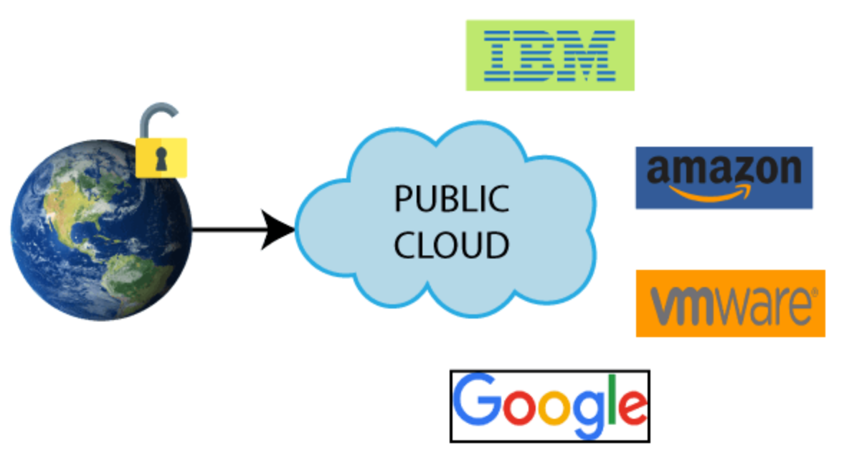

Figure 1: Public deployment

* Advantages:
* Minimal Investment: Since it's a pay-per-use service, there are no significant up-front costs, which makes it perfect for businesses that need quick access to resources.
* No setup cost: Because cloud service providers are paying for the entire infrastructure, no hardware is necessary.
* Infrastructure management is not necessary: Using the public cloud excludes the need for infrastructure administration.
* There is no maintenance because the service provider handles it (Not users).
* Dynamic Scalability: Resources are accessible on demand to fulfill your company's demands.
* Disadvantages:
* Reliability issues: Many users have access to the same server network, making it prone to outages and downtime.
* Data security and privacy concerns: May not provide comprehensive protection against cyberattacks, and public exposure may expose gaps.
* Service/License Limits: There are limits on how much you can use when sharing resources with tenants.

1. Private deployment

According to (Sarfraz Brohi, 2011) Private cloud infrastructure (internal cloud) is dedicated to a single organization or group. It is not distributed to other organizations. Private clouds can be purchased or leased. It can be managed by the organization or by a third party and can exist on or off-premises. When compared to public cloud, private cloud is more expensive and secure. The private cloud is hosted within the organization's firewall. Users within the organization can access it via the intranet, as shown in Figure 2.

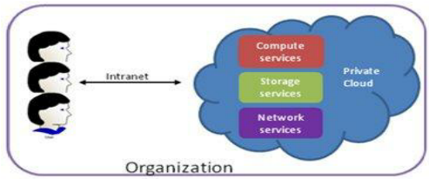

Figure 2: Private deployment

* Advantages:
* More Control: Because only a limited number of users may access private clouds, they have more control over their resources and infrastructure than public clouds do.
* Security & Privacy: One of the major advantages of cloud computing is security and privacy. Compared to public clouds, the security level was higher with private clouds.
* Improved performance: Private cloud offers better performance with improved speed and space capacity.
* Disadvantages
* High cost: Due to the high cost of setting up and maintaining hardware resources, the cost is higher than a public cloud.
* Restricted area of operations: As you know, private clouds are accessible within an organization, so their scope of use is limited.
* Limited scalability: Private clouds are only scaled to the extent that internal hosted resources will allow.
* Skilled people: Skilled people are required to manage and operate cloud services.

(javatpoint, 2022)

1. Community cloud

According to (Sarfraz Brohi, 2011) A community cloud is a shared infrastructure supported by several organizations that serves a specific community with shared concerns, such as mission, security requirements, policy, and compliance considerations. It can be managed by the organizations or by a third party and can be on or off-premises. The community cloud provides a higher level of privacy, security, and policy compliance. Google's "Gov Cloud" is an example of a community cloud.

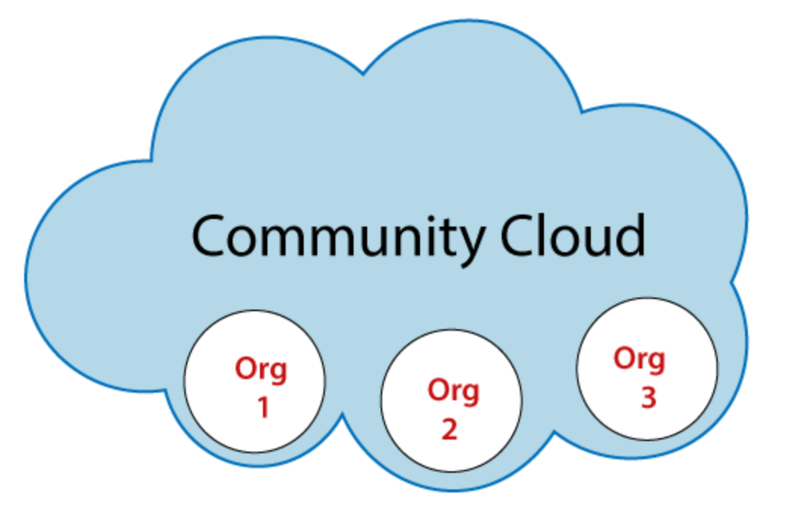

Figure 3: Community cloud

* Advantages:
* Cost effective: Because the entire cloud is shared by numerous enterprises or a community, community clouds are cost-effective.
* Flexible and Scalable: Because it works with every user, the community cloud is adaptable and scalable. Users can alter the documents according to their needs and requirements.
* Security: Public cloud is less secure than community cloud, which is more secure than private cloud.
* Sharing infrastructure: We may share cloud resources, infrastructure, and other capabilities between different enterprises thanks.
* Disadvantages:
* Not all businesses should choose community cloud.
* Data adoption is sluggish.
* All community members share a set amount of data storage and bandwidth.
* Public cloud is less expensive than community cloud.
* It's challenging for organizations to share responsibilities.

1. Hybrid cloud

According to (Sarfraz Brohi, 2011) Applications can run on a hybrid cloud, which combines several different environments. Nowadays, nearly no one completely relies on the public cloud, hence hybrid cloud computing strategies are common. This cloud deployment model exists as a result of an organization's diverse needs. As illustrated in Figure 4, it is a hybrid of two or more cloud service deployment models (Private, Public, and Community). Organizations may host critical applications on private clouds and applications with fewer security concerns on public clouds.

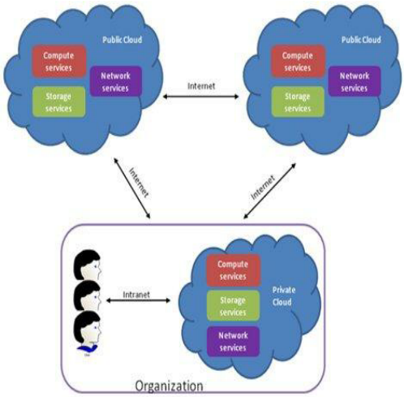

Figure 4: Hybrid cloud

A public and private cloud are joined together to keep business-critical data and services under their control on the private cloud while outsourcing less-critical processing to the public cloud.

* Advantages:
* Flexible and secure: It offers secure resources thanks to the private cloud and flexible resources thanks to the public cloud.
* Cost effective: Private cloud is more expensive than hybrid cloud. It enables businesses to reduce their expenditures on both infrastructure and application support. It provides the advantages of both a public and a private cloud. A hybrid cloud may adjust to the needs each business has in terms of system, memory, and storage space.
* Security: Hybrid cloud is secure since the private cloud handles crucial tasks.
* Risk Management: An good option for businesses to manage risk is through hybrid cloud.
* Disadvantages:
* Networking issues: In the Hybrid Cloud, networking becomes complex because of the private and the public cloud.
* Infrastructure Compatibility: In a hybrid cloud, infrastructure compatibility is the main problem. Dual-level infrastructure makes it possible for them to be operating in different stacks because a private cloud is in control of the organization while a public cloud is not.
* Reliability: The reliability of the services depends on cloud service providers.

(Brohi, 2011)

1. Cloud Server Models
2. Infrastructure as a Service (IAAS)

According to (Sarfraz Brohi, 2011) Infrastructure as a Service (IaaS) In this cloud service delivery model, the provider enables clients to provision processing, storage, networks, and other essential computer resources, allowing clients to deploy and execute any software, including operating systems and applications. Platform virtualization environment is provided as a service via IaaS. Memory, CPU, IP addresses, operating systems, storage, deployed applications, and possibly limited control over some networking components, such as host firewalls, are all within the control of the clients. Clients are not in charge of or manage the cloud infrastructure itself. For clients using the IaaS paradigm, cloud providers must offer a trustworthy host and Virtual Machine Monitoring (VMM) environment. Sun Microsystems, Dropbox, and Amazon EC2 and S3 are a few examples of IaaS providers.

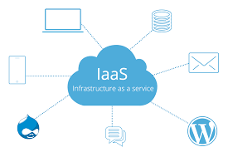

Figure 5: Infrastructure as a Service

* Advantages:
* Shared infrastructure: Multiple users can share the same physical infrastructure thanks to IaaS.
* Web access to the resources: IT users can access resources via the internet thanks to IaaS.
* Pay-as-per-use model: IaaS service providers offer services on a pay-per-use basis. Users must pay for the resources they have consumed.
* Focus on the core business: IaaS suppliers prioritize the core operations of the company over IT infrastructure.
* On-demand scalability: One of the main benefits of IaaS is its capacity to scale on demand. Users that utilize IaaS don't have to worry about updating software or troubleshooting hardware-related problems.
* Disadvantages:
* Security: One of the main problems with IaaS is security. The majority of IaaS companies are unable to provide complete security.
* Maintenance & Upgrade: Although IaaS service providers update the software for some firms, they do not for others.
* Interoperability issues: Since it is challenging to move virtual machines across IaaS providers, users may experience vendor lock-in issues.

1. Platform as a Service (PAAS)

According to (Sarfraz Brohi, 2011) In this model, the provider enables the customers to deploy their own or purchased applications on the cloud infrastructure via the internet using Application Program Interfaces (APIs) or website portals. Programming language platforms and software examples include but are not limited to Java, Python, or.Net. Services like virtual development environments, application standards based on the needs of the developers, configured toolkits for virtual development environments, and ready-made distribution channels for public application developers are all made available by PaaS providers to application developers. The configurations of the application hosting environment and potentially the deployed apps are within the control of the clients. Clients do not, however, have control over the network, servers, operating systems, or storage that make up the underlying cloud infrastructure. In the PaaS model, the cloud provider is in charge of maintaining the security of the computing environment and the development environment, while the clients are responsible for maintaining the security of their own apps. Microsoft Azure, Force.com, and Google App Engine are a few examples of PaaS services.

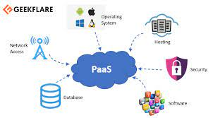

Figure 6: Platform as a Service

* Advantages:
* Simplified Development: Developers can concentrate on creating and innovating instead of worrying about managing infrastructure thanks to PaaS.
* Lower risk: There is no requirement for initial hardware and software investments. To begin creating applications, developers merely need a PC and an internet connection.
* Prebuilt business functionality: Some PaaS providers additionally offer pre-built business functionality so that users can avoid starting from scratch and can instead focus solely on their projects.
* Instant community: Online communities are typically offered by PaaS companies so that developers may acquire ideas, exchange experiences, and get assistance from others.
* Scalability: Without altering the apps, deployed applications can scale from one to thousands of users.
* Disadvantages:
* Vendor lock-in: Application migration to another PaaS vendor would be problematic since one must write applications in accordance with the platform supplied by the PaaS vendor.
* Data Privacy: Corporate data is private, regardless of whether it is important or not, so there may be a privacy risk if it is stored outside of the boundaries of the business.
* Integration with the rest of the systems applications: Some applications might be local while others might be in the cloud. Therefore, there is a potential that complexity would increase if we want to combine local data with cloud data.

1. Software as a Service (SAAS)

According to (Sarfraz Brohi, 2011) In this concept, a thin client interface, such as a web browser over the internet, is used to provide clients with licensed applications running on a cloud infrastructure, with a pay-per-use pricing model. Clients are not required to manage or control the network, servers, operating systems, or storage that make up the underlying cloud infrastructure. Right now, SaaS is the ideal access paradigm for lightweight programs like word processors and music players. SaaS performance, however, may suffer because of buffering time when it comes to demanding apps like playing online 3D games. Many companies, including Google Docs, Apple's MobileMe, and Zoho Suite, offer SaaS. In a virtualized cloud environment, the provider often lives on a particular virtual machine and maintains the client-hired applications there.

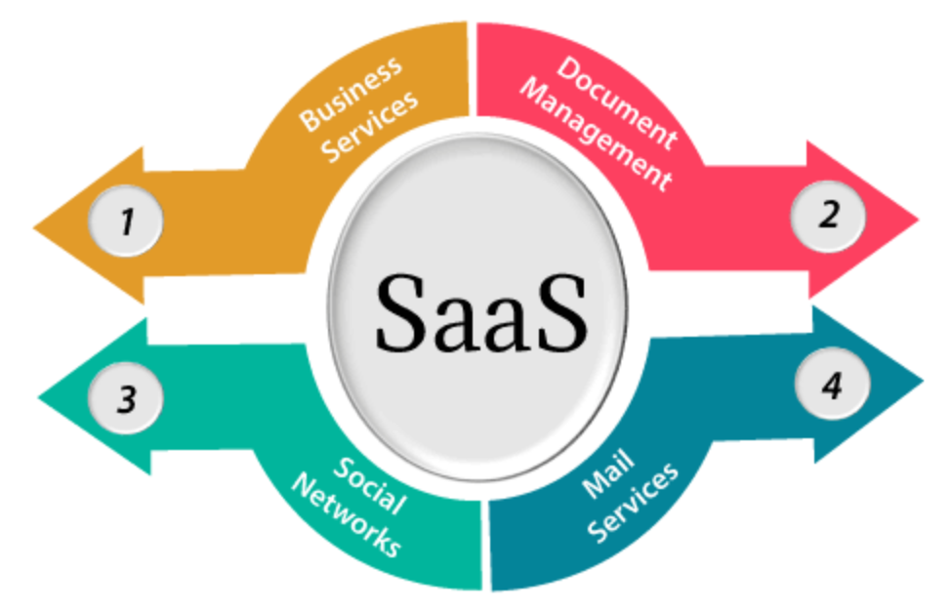

Figure 7: Software as a Service

* Advantages:
* SaaS is easy to buy: Business functionality can be accessed by companies at a cheap cost, which is less expensive than licensed programs, thanks to SaaS pricing, which is based on a monthly or annual price subscription. SaaS suppliers typically charge a subscription fee for the use of the apps, most frequently a monthly or annual price. This is in contrast to traditional software, which is offered as licensed basis with an upfront cost (and frequently an optional ongoing maintenance fee).
* One to Many: One-to-many models, which are how SaaS services are provided, allow several users to share a single instance of the program.
* Less hardware required for SaaS: Since the software is remotely hosted, businesses do not need to make supplemental hardware investments.
* Low maintenance required for SaaS: The need for installation, setup, and ongoing maintenance for the organizations is eliminated by software as a service. In comparison to enterprise software, SaaS often has lower initial setup costs. Vendors of software as a service (SaaS) charge different prices for different usage parameters, like the quantity of users. SaaS offers automatic upgrades
* No special software or hardware versions required: The program is often accessed using a web browser, and all users will have the same version of it. By contracting out hardware and software maintenance and support to the IaaS provider, SaaS lowers IT support expenses.
* Multidevice support: Any device, including PCs, laptops, tablets, phones, and thin clients, can access SaaS services.
* API Integration: Through common APIs, SaaS services are simple to combine with other programs or services.
* No client-side installation: SaaS services don't need to require any software installation because they may be accessed straight from the service provider utilizing an internet connection.
* Disadvantages:
* Security: Security may be a concern for certain users because data is actually kept in the cloud. However, compared to internal deployment, cloud computing is not more secure.
* Latency issue: In comparison to local deployment, there is a chance that there may be more latency while interacting with the application because data and apps are kept in the cloud at varying distances from the end-user. As a result, the SaaS model is inappropriate for applications with millisecond-level demand response times.
* Total Dependency on Internet: Most SaaS programs cannot be used without an internet connection.
* Switching between SaaS vendors is difficult: When switching SaaS providers, it is necessary to transfer very large data files over the internet, convert them, and then import them into a new SaaS.

(Brohi, 2011)

1. Characteristic of Cloud

Cloud computing has five essential characteristics. It is not cloud computing if any of these qualities are missing.

* On-demand self-services: Users of cloud computing services have the ability to provision, monitor, and manage computing resources as necessary without the assistance of human administrators.
* Broad network access: Computing services are typically offered over established networks and a variety of hardware.
* Rapid elasticity: The IT resources for the computing services should be able to scale up and down quickly as needed. When a user requests a service, it is delivered to him, and after that service's demand is met, it is scaled out.
* Resource pooling: Multiple applications and occupants share the available IT resources (such as networks, servers, storage, applications, and services) in an ad hoc way. From the same physical resource, services are given to numerous clients.
* Measured service: Each application and occupant's resource usage is monitored, giving both the user and the resource supplier a record of what has been consumed. This is done for a number of purposes, including effective resource management and billing oversight.

# Virtualization and Multicore

1. Virtualization

Creating a virtual (rather than actual) version of something, such as a server, desktop, storage device, operating system, or network resources, is known as virtualization.

In other terms, virtualization is a technique that enables numerous consumers and organizations to share a single physical instance of a resource or an application. It accomplishes this by giving a physical storage a logical name and supplying a pointer to that physical resource when needed.

Types of Virtualization:

* Hardware Virtualization.
* Operating system Virtualization.
* Server Virtualization.
* Storage Virtualization.

1. Multicore

* Through the use of multicore technology, two or more CPUs coexist on the same chip. In this architecture, the core logic of two or more processors is combined into a single physical processor. This integrated circuit contains these CPUs as separate units (IC). One IC makes up a die. Another definition of multicore technology is several dies packed together. With the help of this technology, the system is able to do more tasks while performing better as a whole. Additionally, it helps to reduce power consumption and achieve more effective, concurrent processing of numerous tasks. Desktop computers, mobile personal computers (PCs), servers, and workstations all use multicore technology. As a result, in a multitenant cloud environment, this technology is used to speed up processing.
* Virtualized applications that are CPU and memory heavy should scale to the maximum limits of the memory architecture. In the multicore processor-based cloud system, cutting-edge computer architectures are used to permit several VMs to proliferate provided that cache, memory, bus, and network bandwidth limitations are not exceeded.
* A significant development in modern architecture has been the introduction of multicore CPUs in processor architecture. Parallelism is made available to programmers in multicore circuits because multiple smaller processors are employed instead of a single large one. How effectively multicore CPUs are used in today's server clouds to get real performance benefits is the main concern.

1. Solution for ATN
2. Scenario

ATN is a Vietnamese company which is selling toys to teenagers in many provinces all over Vietnam. The company has the revenue over 700.000 dollars/year. Currently each shop has its own database to store transactions for that shop only. Each shop has to send the sale data to the board director monthly and the board director need lots of time to summarize the data collected from all the shops. Besides the board can’t see the stock information update in real time.

1. Solution

According to the aforementioned scenario, ATN should adopt cloud computing services since they allow branch managers to manage all of the branch's stored data from any location they choose, whenever they need to. require and have access to the internet. As it enables store managers and staff to access it without any understanding or experience in that technology, people can readily access it. Utilizing business cloud will address all issues with data loss and catastrophe preparedness.

1. Deployment Model

Each of these cloud computing models helps the business run more efficiently and profitably. However, because of the company's 700,000 USD yearly revenue and the requirement for a small to medium-sized model at a reasonable cost, I advise the company to choose public cloud. A cheap or even free deployment model is the public cloud. All employees from branch stores and managers may utilize the service, as public cloud does not place any restrictions on its use. Additionally, the community cloud service is not location-dependent. As long as an internet connection is needed, all of the company's linked stores can use the service. Nearly all public cloud service providers promise over 99% uptime and zero failure risk. Since numerous servers are connected by the overall cloud system, in the event of any specific breakdown, the other server instantly assumes the workload, ensuring a seamless and unhindered business operation.

1. Service Model

We advise utilizing cloud computing. PaaS service, as it has recently been used successfully by organizations, especially smaller ones like ATN, to use the potential of cloud computing. calculation in math. I decided to use PaaS because of how easy and convenient it is for users. PaaS is provided and supported by a number of clouds, including public clouds. The cloud provider will offer all the key IT elements required to host the application, such as servers, storage systems, networks, operating systems, and databases. Utilizing PaaS lowers investment expenses for things like server space, programming environment software, security, and ongoing maintenance. PaaS facilitates global collaboration. Companies all across the world may enhance workflows and develop effective procedures thanks to PaaS.

1. Technical Specs
   1. NodeJS

Here is a formal definition provided on the official Node.js website, according to (Nodejs, n.d.):

* Node.js® is a JavaScript runtime built on Chrome’s V8 JavaScript engine.
* Node.js handles I/O directly, therefore unless synchronous Node.js standard library methods are used, the process never blocks.
* Node.js’ package ecosystem, npm, is the largest ecosystem of open-source libraries in the world.

Node.js has a distinct benefit since it allows the millions of frontend developers who write JavaScript for the browser to create both server-side and client-side code without having to switch to a new language.

Node.js' design is reminiscent of and influenced by programs like Twisted in Python and Ruby's Event Machine. The event concept is expanded upon a little in Node.js. Instead of presenting an event loop as a library, it offers it as a runtime construct. In other systems, the event-loop is always initiated by a blocking call. Typically, callbacks are used to establish behavior at the beginning of a script, and blocking calls like EventMachine::run are used to start a server at the conclusion (). There is no equivalent start-the-event-loop call in Node.js. After the input script has been run, Node.js just joins the event loop. When there are no more callbacks to execute, Node.js terminates the event loop. The event loop is concealed from the user in this behavior, similar to browser JavaScript.

Node.js was created with streaming and low latency in mind, and HTTP is treated as a first-class citizen. Because of this, Node.js is a good choice as the base for a web library or framework.

Despite Node.js' lack of threading, you can still utilize several cores in your environment. Our child process.fork() API can be used to spawn child processes, which are made to be simple to interact with. The cluster module, which is based on the same interface, enables you to share sockets amongst processes to enable load balancing over your cores.

Because of various benefits, Node.js is the programming language I use, and that is why we decided to adopt it:

* Node.js handles I/O directly, therefore unless synchronous Node.js standard library methods are used, the process never blocks.
* Node.js’ package ecosystem, npm, is the largest ecosystem of open-source libraries in the world.
* The cross-platform framework that runs on Windows, MAC or Linux.

(NodeJs, n.d.)

* 1. MongoDB

MongoDB is a document database with the scalability, flexibility, and querying and indexing capabilities that you want. They also provide support for more than ten different languages.

I use MongoDB in the project for a number of reasons, including the following:

* MongoDB is free to use
* The document model in MongoDB is easy to use and learn for developers.
* MongoDB stores data as adaptable documents that resemble JSON, which allow fields to alter from document to document and allow data structures to change over time.
* Data manipulation is made simple by the document model, which corresponds to the objects in your application code.
* Powerful methods for accessing and analyzing your data include ad hoc queries, indexing, and real-time aggregation.
* As a distributed database at its core, MongoDB has built-in support for high availability, horizontal scaling, and geographic distribution.

(MongoDB, n.d.)

* 1. Render

In addition to offering free TLS certificates, a worldwide CDN, DDOS protection, private networks, and auto deployments from Git, Render is a single cloud for building and running all of your apps and websites.

* To increase developer productivity, Render Experience offers services, tools, workflows, and polyglot support.
* Render is very easy to use, fast and effective.
* For HTTP queries, Render permits response times of up to 100 minutes. Heroku features a 30 second enforced response timeout that cannot be modified or altered.
* IP access control is incorporated into Render's Redis instances as an additional security measure.
* Cloudflare's cutting-edge DDoS protection is enabled for all Render applications.
* Your apps' HTTP answers are automatically compressed by Render's load balancers utilizing Brotli and gzip compression, which substantially speeds up your Render apps, especially over mobile and low bandwidth connections.
* Render integrates seamlessly with GitHub.

(render, n.d.)

# Conclusion

In the aforementioned report, I gave a general review of cloud computing, outlining its definition as well as its features and societal advantages. I provided the approach and justification using the circumstances at hand so that I could select cloud computing over other management.

# References

Brohi, S., 2011. *Exploring the Cloud Deployment and Service Delivery Models.* [Online]   
Available at: https://www.researchgate.net/publication/257995661_Exploring_the_Cloud_Deployment_and_Service_Delivery_Models

FRANKENFIELD, J., 2022. *What is Cloud Computing? Pros and Cons of Different Types of Services.* [Online]   
Available at: https://www.investopedia.com/terms/c/cloud-computing.asp

MongoDB, n.d. [Online]   
Available at: https://www.mongodb.com/what-is-mongodb

NodeJs, n.d. [Online]   
Available at: https://nodejs.org/en/about/

render, n.d. [Online]   
Available at: https://render.com/

rizafennisya.files.wordpress, 2022. *Client/server and peer-to-peer models: basic concepts.* [Online]   
Available at: https://rizafennisya.files.wordpress.com/2017/01/14-client-server-and-peer-to-peer-models.pdf

techopedia, 2022. *Multicore.* [Online]   
Available at: https://www.techopedia.com/definition/5305/multicore

tutorialspoint, 2022. *What is Cluster Computing?.* [Online]   
Available at: https://www.tutorialspoint.com/what-is-cluster-computing